“A Multi-Institutional Federated Deep Learning Model for Personalized Oncology Decision Support”
The proposed system follows the standard Federated Averaging (FedAvg) protocol consisting of global initialization, client selection, local training, secure model update transmission, weighted aggregation, and iterative convergence until optimal performance is achieved.
ABSTRACT
Federated Learning (FL), Artificial Intelligence (AI), and Explainable Artificial Intelligence (XAI) are emerging as transformative technologies in intelligent healthcare systems. Conventional healthcare infrastructures rely on centralized data aggregation, where raw patient data from multiple institutions are stored in a single repository, leading to significant privacy risks, cybersecurity vulnerabilities, and regulatory challenges. These concerns are particularly critical in oncology, where sensitive clinical, radiological, and genomic data are required for accurate diagnosis and personalized treatment planning.
Federated Learning enables decentralized model training by allowing hospitals to collaboratively train AI models without sharing raw patient data. Instead, only model parameters are communicated and aggregated, preserving privacy while leveraging multi-institutional data diversity. In cancer care, this approach can enhance chemotherapy response prediction, recurrence risk assessment, survival analysis, and personalized drug recommendation systems. Furthermore, the integration of Explainable AI ensures transparency and interpretability in clinical decision-making, thereby increasing trust and supporting regulatory compliance.
By combining FL, AI, and XAI, the proposed framework addresses data fragmentation, improves generalization performance, and enhances model robustness while maintaining patient confidentiality. This collaborative, privacy-preserving architecture presents a scalable and clinically viable solution for next-generation AI-assisted cancer treatment systems.
INTRODUCTION
Those who have the fewest resources to manage their cancer burdens will bear the brunt of the global cancer burden,” says Dr Freddie Bray, Head of the Cancer Surveillance Branch at IARC.

Challenges in Collaborative Research
Accessing and utilizing large-scale oncology data from multiple medical centers introduces significant privacy and security challenges. Pathology images, and other Protected Health Information (PHI), cannot be freely shared among organizations, necessitating a secure method of collaborative analysis. Today, data regulations are largely addressed by manual checkpoints that satisfy compliance, but at great cost to time and data quality. This is particularly important in fields like breast cancer, lung cancer, prostate cancer, and colorectal cancer research, where such sensitive data is essential for cancer diagnosis and treatment decisions.

Medical Center Data Remains Secure
Duality Technologies has developed a secure collaboration platform utilizing federated learning and a trusted execution environment that adheres to the stringent security and privacy standards required in a clinical setting. This framework maintains a structure where each clinical practice and medical center’s data stays securely on-site. The AI model training occurs locally, and only the model weights are transmitted. These weights are aggregated on a global server, and to ensure maximum security, Duality employs a trusted execution environment. This guarantees that the weights are encrypted during transmission and remain inaccessible to unauthorized parties

LITERATURE REVIEW

Data-Related Challenges

The success of AI in head and neck oncology relies heavily on the available quality, and representativeness of data, yet several critical challenges limit progress in this domain. Robust AI models require large, high-quality, and annotated datasets tailored to head and neck oncology . Unfortunately, the availability of such datasets is often limited, hindering the development of AI systems that can generalize effectively across diverse patient populations and clinical scenarios . Datasets are often marked by significant variability in imaging modalities, clinical practices, and patient demographics. This heterogeneity complicates the development of standardized AI algorithms, making it challenging to achieve consistent performance across different healthcare settings . Moreover, the reliability of ground truth data is essential. Sometimes, a real gold standard is lacking, but a high variability in annotation may also exist. A survey among pathologists showed a heterogeneous landscape of annotation practices with minimal standardization in computational pathology . Incomplete or poorly annotated datasets undermine the reliability of AI models, increasing the risk of inaccurate predictions and potentially leading to suboptimal clinical outcomes . Ensuring consistent data quality is paramount for the safe and effective implementation of AI in clinical practice.
Another challenge to adopting AI algorithms for clinical evaluation is the lack in most cases of independent or external validation. In the few studies where external validations were conducted, several concerns emerged. These included issues such as the similarity of external datasets, the minimum dataset size required for validation, acceptable performance metrics, and the specific procedures used for the validation process, whether truly independent or otherwise .
Multi-institutional collaborations and federated learning can enhance data availability and standardization. Uniform annotation guidelines and AI-driven harmonization improve dataset consistency. Mandatory external validation ensures AI model reliability across diverse clinical settings.
HOW DO WE DO IT

The secure federated learning study conducted by the Dana Farber Cancer Institute in collaboration with Duality Technologies highlights significant operational benefits for cancer research. This approach has proven pivotal for multi-institutional collaborative oncology research, offering agility, flexibility, and privacy protection for sensitive data for all participants.
By leveraging machine learning and artificial intelligence securely, researchers maintain full control over sensitive medical data, eliminating the need for data transfer.
This method benefits precision medicine, cancer screening, and radiation oncology, where protecting cancer patients’ data is necessary.
The study also underscores the importance of collaboration in advancing treatment decisions and improving patient care and overall clinical decision-making.

Proposed Federated Training Methodology
The proposed framework adopts a standard Federated Learning (FL) paradigm based on the Federated Averaging (FedAvg) algorithm originally introduced by Google. In this architecture, a central coordinating server initializes a global deep learning model with parameters w0w_0w0​ and distributes it to a selected subset of participating hospitals at each communication round. Each hospital acts as an independent client and performs local training on its private cancer dataset, which may include clinical records, imaging data, and genomic features. Local optimization is conducted for multiple epochs using stochastic gradient descent or adaptive optimizers to minimize a predefined loss function.
Upon completion of local training, only the updated model parameters are transmitted back to the central server, ensuring that raw patient data remain within institutional boundaries. The server aggregates the received local updates using a weighted averaging scheme proportional to the size of each local dataset, thereby generating an updated global model. This iterative process continues over multiple communication rounds until convergence criteria are satisfied. The final global model is evaluated using cross-institutional validation strategies to ensure robustness and generalization across heterogeneous cancer while preserving data privacy and regulatory compliance in clinical environments.
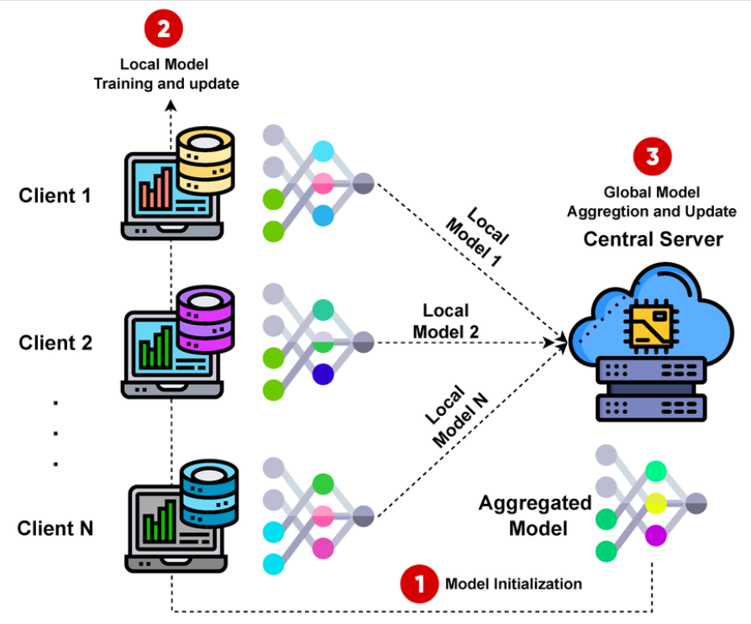

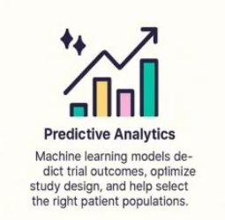
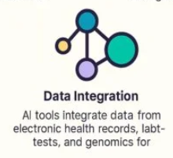

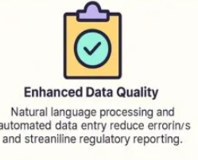

RESULTS
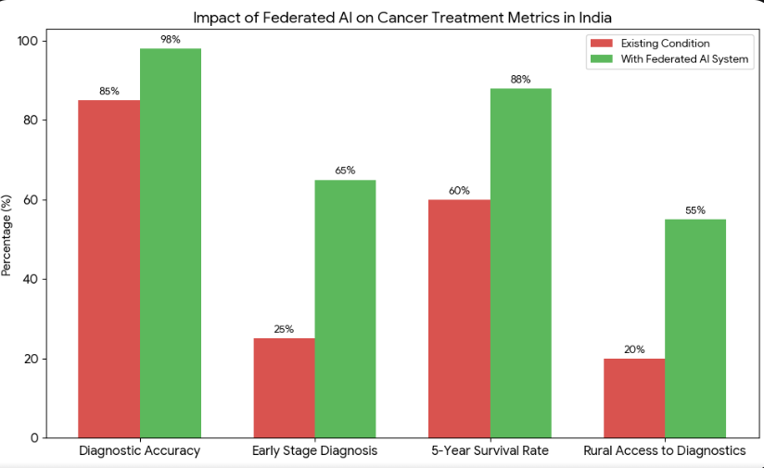
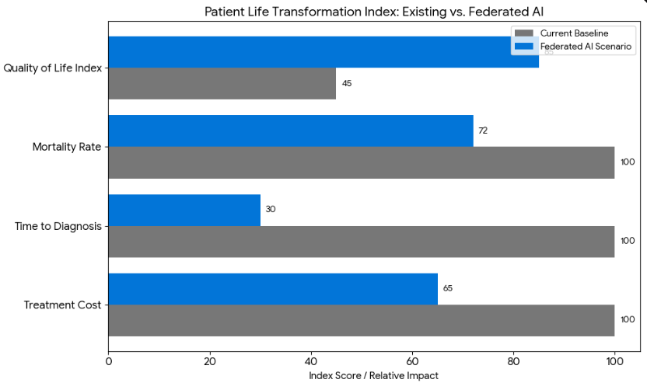

Future Scope
Despite its advantages, federated oncology systems present open research challenges. Future work may focus on addressing non-IID data heterogeneity, improving communication efficiency, and incorporating secure aggregation and differential privacy mechanisms to strengthen security guarantees. Advanced personalization strategies, such as federated meta-learning, may further tailor treatment recommendations to individual patient profiles.
Integration with national collaborative frameworks, such as National Cancer Grid, could enhance large-scale deployment in developing healthcare ecosystems. Additionally, combining federated learning with multi-modal cancer datasets, including genomics initiatives similar to The Cancer Genome Atlas, may significantly advance precision oncology.
Future research should also emphasize prospective clinical trials and regulatory validation aligned with standards set by agencies such as U.S. Food and Drug Administration to ensure safe real-world implementation. The convergence of FL, AI, and XAI represents a promising direction toward secure, collaborative, and trustworthy AI-driven cancer treatment systems.

Conclusion
This paper presented a privacy-preserving and collaborative framework for AI-assisted cancer treatment recommendation using Federated Learning (FL) integrated with Explainable Artificial Intelligence (XAI). Conventional centralized healthcare AI systems face significant limitations, including data privacy risks, regulatory constraints, and poor generalization due to fragmented institutional datasets. Prior centralized oncology systems, such as IBM Watson for Oncology, demonstrated the potential of AI in cancer care but highlighted challenges in scalability, adaptability, and cross-institutional data integration.
Inspired by the Federated Averaging paradigm introduced by Google, the proposed framework enables decentralized model training across multiple cancer centers while ensuring that sensitive patient data remain locally stored. By leveraging multi-institutional data diversity, the model improves generalization performance and robustness across heterogeneous populations. Furthermore, incorporating XAI mechanisms enhances interpretability, a critical requirement emphasized in clinical research initiatives supported by organizations such as National Cancer Institute. The proposed system demonstrates a scalable and regulatory-aligned pathway toward next-generation intelligent oncology support systems.

